**DAILY ONLINE ACTIVITIES SUMMARY**

|  |  |  |  |  |  |  |  |  |
| --- | --- | --- | --- | --- | --- | --- | --- | --- |
| **Date:** | **30/06/2020** | | | | | **Name:** | **Lavanya D M** | |
| **Sem & Sec** | **4th & ‘A’** | | | | | **USN:** | **4al18cs041** | |
| **Online Test Summary** | | | | | | | | |
| **Subject** | | **----** | | | | | | |
| **Max. Marks** | | **----** | | **Score** | | | **-----** | |
| **Certification Course Summary** | | | | | | | | |
| **Course** | EIGRP Course | | | | | | | |
| **Certificate Provider** | | | **Bitdegree** | | **Duration** | | | **1week** |
| **Coding Challenges** | | | | | | | | |
| **Problem Statement:**  1) Write a C Program to generate first n Ugly Numbers  2) Write a C++ Program to Move all zeroes to end of array using Two-Pointers | | | | | | | | |
| **Status: Complied** | | | | | | | | |
| **Uploaded the report in Github** | | | | | **yes** | | | |
| **If yes Repository name** | | | | | <https://github.com/lavanyamurthi/lockdown-coding> | | | |
| **Uploaded the report in slack** | | | | | **yes** | | | |

Online Test Details: (Attach the snapshot and briefly write the report for the same)

No test conducted

Webinar:

Today class is conducted on C++ Programming by Shruthi Shetty ma’am in which we learn about the concept of C++ Programming, and even we had quiz regarding that

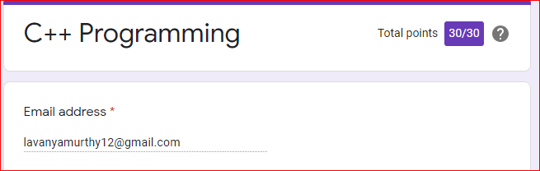

Certification Course Details: (Attach the snapshot and briefly write the report for the same)



Coding Challenges Details: (Attach the snapshot and briefly write the report for the same)

**Problem 1** : Write a C Program to generate first n Ugly Numbers

Ugly numbers are those number whose prime factors are 2, 3 or 5. From 1 to 15, there are 11 ugly numbers 1, 2, 3, 4, 5, 6, 8, 9, 10, 12, 15. The numbers 7, 11, 13 are not ugly because they are prime. The number 14 is not ugly because in its prime factor the 7 will come.

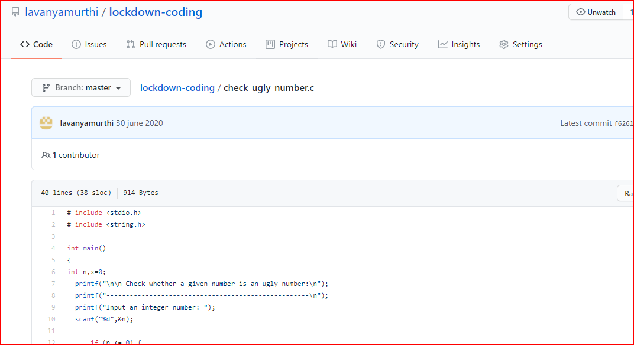

|  |
| --- |
|  |
|  |  |

**Problem 2:**  Write a C++ Program to Move all zeroes to end of array using Two-Pointers

Given an array of random numbers, Push all the zero’s of the given array to the end of the array. For example, if the given arrays is {1, 0, 2, 6, 0, 4}, it should be changed to {1, 2, 6, 4, 0, 0}. The order of all other elements should be the same.

Examples:

Input: arr[]={8, 9, 0, 1, 2, 0, 3}  
Output: arr[]={8, 9, 1, 2, 3, 0, 0}  
Explanation:  
Swap {0 ,1} -> Resulting array {8, 9, 1, 0, 2, 0, 3}  
Swap {0 ,2} -> Resulting array {8, 9, 1, 2, 0, 0, 3}  
Swap {0 ,3} -> Final array {8, 9, 1, 2, 3, 0, 0}

Input: arr[]={4, 5, 0, 0, 0, 0, 6, 7}  
Output: arr[]={4, 5, 6, 7, 0, 0, 0, 0}

